Tracing prints from the crime scene to the criminal!!


Analysis of fingerprints is probably the most well known use of forensic science. Each fingertip has a pattern of fine skin ridges that are slightly different for every person - even identical twins.

A fingerprint sample is composed of grease and dried sweat left behind by the tips of the fingers. The palms of the hand also leave identifiable prints, as do the soles of the feet.

Fingerprints can be detected on a vast range of different surfaces using a variety of techniques. The police keep a huge national database of prints taken from charged criminals. New prints are taken by a laser-scanning procedure, where the hand is placed on a flat glass plate, and its print is stored and compared to other prints electronically.

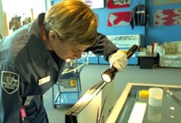
A rough estimation is that between 5 and 15 % of the world population is fingerprinted and has its prints on files. Computers all over the world constantly match millions of records per second penetrating collections in depth even with fragments of prints and generate fast results. The axiom that not two persons have the same fingerprints is already firmly based. With the comparison of billions of prints per day, the opposite is never found, so the uniqueness is constantly confirmed in an unprecedented way

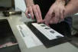
Above: Searching for traces of evidence at the crime scene.
Right: Taking a fingerprint sample.

Back to the beginning

Fingerprints are made of ridges on the skin on the hands. It is thought that they are formed during pregnancy in a mechanism involving how the blood flows over the skin of the unborn baby.
- Your fingerprint does not change from the day you are born until the day you die
- .Even identical twins, though they have the same DNA, have completely different fingerprints.
- As long ago as 1750 BC, people in Babylon used fingerprints to sign their identity on clay tablets.


Definition time!!
- Datcyloscopy is the study of fingerprints for identification purposes
- Latent prints are invisible prints that are made by the perspiration and oils that gather naturally in the fingers.

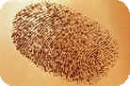
Interesting Fact:

Taking fingerprints from the recently dead is not generally difficult once rigor mortis has passed, but older corpses present problems. Skin often peels from drowning victims, and forensic technicians may have to wrap it around their own fingers to take prints!!

